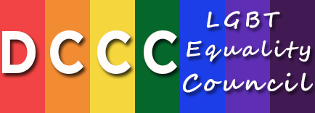

**Hon. Jared Polis, LGBT Equality Council Chair**

**2015 Schedule of Events**

**March 2015**

DCCC Santa Fe Issues Conference

**May 2015**

LGBT Equality Council Conference Call

**June 2015**

New York City Planning Breakfast

Washington, DC Signature Event

**August 2015**

LGBT Equality Council Conference Call

DCCC Speaker’s Cabinet Napa Valley Issues Conference

**September 2015**

New York City Signature Event

**November 2015**

LGBT Equality Council Conference Call

***For further information, please contact Adam Blackwell at (202) 485-3450 or by email at blackwell@dccc.org****.*

|  |
| --- |
| Paid for by the Democratic Congressional Campaign Committee. 430 South Capitol Street, S.E. – Washington, D.C. 20003– 202.863.1500 – [www.DCCC.org](http://www.DCCC.org)  Not authorized by any candidate or candidate’s committee. |